YASHODHA NAIK
1NT20IS416

PROGRAM 3
package WORD;

import java.io.IOException;
import java.util.*;
import org.apache.hadoop.fs.Path;
import org.apache.hadoop.io.IntWritable;
import org.apache.hadoop.io.LongWritable;
import org.apache.hadoop.io.Text;
import org.apache.hadoop.mapred.FileInputFormat;
import org.apache.hadoop.mapred.FileOutputFormat;
import org.apache.hadoop.mapred.JobClient;
import org.apache.hadoop.mapred.JobConf;
import org.apache.hadoop.mapred.MapReduceBase;
import org.apache.hadoop.mapred.Mapper;
import org.apache.hadoop.mapred.OutputCollector;
import org.apache.hadoop.mapred.Reducer;
import org.apache.hadoop.mapred.Reporter;
import org.apache.hadoop.mapred.TextOutputFormat;
import org.apache.hadoop.mapred.TextInputFormat;
public class WordCount {
public static class Map extends MapReduceBase implements
Mapper<LongWritable, Text, Text, IntWritable> {
private final static IntWritable one = new IntWritable(1);
private Text word = new Text();
public void map(LongWritable key, Text value, OutputCollector<Text, IntWritable>
output, Reporter reporter) throws IOException {
String line = value.toString();
StringTokenizer tokenizer = new StringTokenizer(line);
while (tokenizer.hasMoreTokens()) {
word.set(tokenizer.nextToken());
output.collect(word, one);
}
}
}
public static class Reduce extends MapReduceBase implements
Reducer<Text, IntWritable, Text, IntWritable> {
public void reduce(Text key, Iterator<IntWritable> values,
OutputCollector<Text, IntWritable> output, Reporter reporter)
throws IOException {
int sum = 0;
while (values.hasNext()) {
sum += values.next().get();
}
output.collect(key, new IntWritable(sum));
}
}
public static void main(String[] args) throws Exception {
JobConf conf = new JobConf(WordCount.class);
conf.setJobName("wordcount");
conf.setOutputKeyClass(Text.class);
conf.setOutputValueClass(IntWritable.class);
conf.setMapperClass(Map.class);
conf.setCombinerClass(Reduce.class);
conf.setReducerClass(Reduce.class);
conf.setInputFormat(TextInputFormat.class);
conf.setOutputFormat(TextOutputFormat.class);
FileInputFormat.setInputPaths(conf, new Path(args[0]));
FileOutputFormat.setOutputPath(conf, new Path(args[1]));
JobClient.runJob(conf);
}
}

4TH PROGRAM

1Use the Hadoop framework to write a MapReduce program to read a .csv file into a single node Hadoop cluster containing following fields Sl. No. CARD name UserName Amount withdrawn Implement the following, 1. Count the Number of transactions done by each user 2. Find the total amount of money transacted by each user
TRANSACTIION.JAVA
package WORD;

import java.io.IOException;
import java.util.*;
import org.apache.hadoop.fs.Path;
import org.apache.hadoop.io.*;
import org.apache.hadoop.mapred.*;

public class Transaction {
//MAPPER CODE

public static class Map extends MapReduceBase implements
Mapper<LongWritable, Text, Text, IntWritable> {
private final static IntWritable one = new IntWritable(1);
//private Text word = new Text();

public void map(LongWritable key, Text value, OutputCollector<Text,
IntWritable> output, Reporter reporter) throws IOException {
String myString = value.toString();
String[] userCount = myString.split(",");
output.collect(new Text(userCount[3]), one);

}
}

//REDUCER CODE
public static class Reduce extends MapReduceBase implements
Reducer<Text, IntWritable, Text, IntWritable> {
public void reduce(Text key, Iterator<IntWritable> values,
OutputCollector<Text, IntWritable> output, Reporter reporter) throws
IOException { //{little: {1,1}}
int finaluserCount = 0 ;
Text mykey = key ;
while(values.hasNext()) {
IntWritable value = values.next();
finaluserCount += value.get();
}
output.collect(mykey, new IntWritable(finaluserCount));
}
}
//DRIVER CODE
public static void main(String[] args) throws Exception {
JobConf conf = new JobConf(Transaction.class);
conf.setJobName("wordcount");
conf.setOutputKeyClass(Text.class);
conf.setOutputValueClass(IntWritable.class);
conf.setMapperClass(Map.class);
conf.setCombinerClass(Reduce.class);
conf.setReducerClass(Reduce.class);
conf.setInputFormat(TextInputFormat.class);
conf.setOutputFormat(TextOutputFormat.class);
FileInputFormat.setInputPaths(conf, new Path(args[0]));
FileOutputFormat.setOutputPath(conf, new Path(args[1]));
JobClient.runJob(conf);
}

}

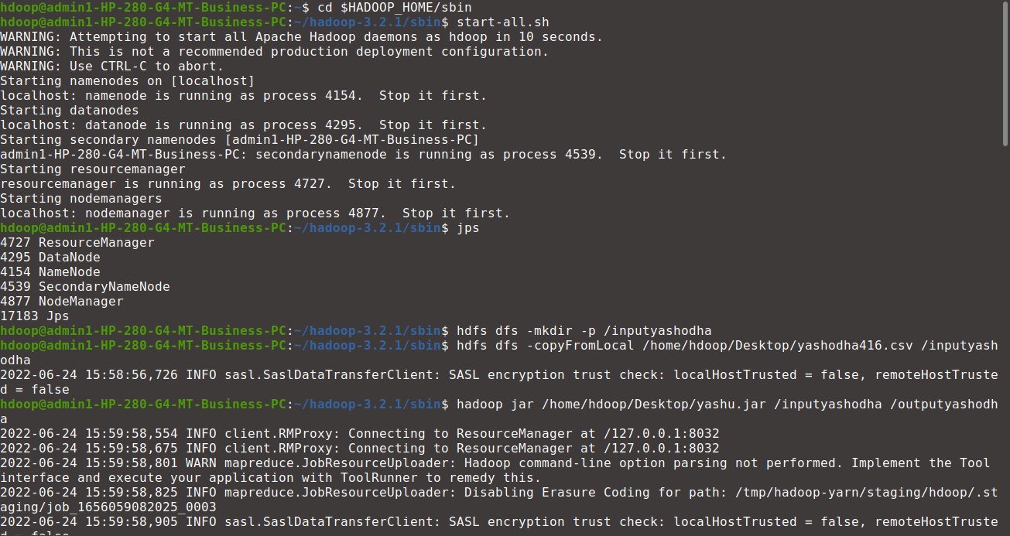

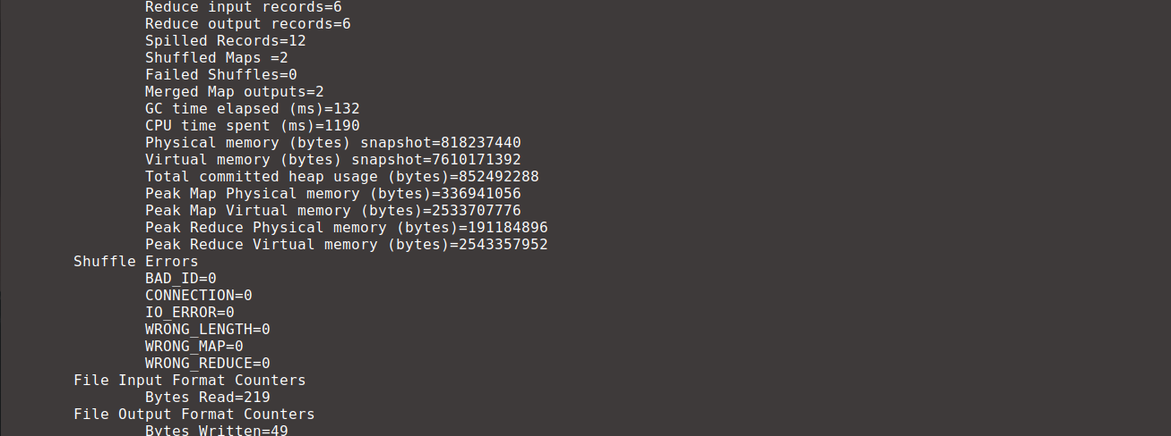

hdoop@admin1-HP-280-G4-MT-Business-PC:~/hadoop-3.2.1/sbin$ hdfs dfs -cat /outputyashodha/part*
